Regression Model to Predict Bike Sharing Demand

Kunal R Kodarlikar

Cohart-Boston

# Abstract: - Rental Bike Sharing is the process by which bicycles are procured on several basis- hourly, weekly, membership-wise, etc. This phenomenon has seen its stock rise to considerable levels due to a global effort towards reducing the carbon footprint, leading to climate change, unprecedented natural disasters, ozone layer depletion, and other environmental anomalies.

**In our project, we chose to analyze a dataset pertaining to Rental Bike Demand from South Korean city of Seoul, comprising of climatic variables like Temperature, Humidity, Rainfall, Snowfall, Dew Point Temperature, and others. For the available raw data, firstly, a through pre-processing was done after which a Here, hourly rental bike count is the regress and. To an extent, our linear model was able to explain the factors orchestrating the hourly demand of rental bikes.**

***Keywords: -*** *Data Mining, Linear Regression, Correlation Analysis, Bike Sharing Demand Prediction, Carbon Footprint.*

# INTRODUCTION

Bike Sharing systems are a means of renting bicycles where the process of obtaining membership, rental, and bike return is automated via a network of kiosk locations throughout a city. Using these systems, people are able rent a bike from a one location and return it to a different place on an as-needed basis.

The first bike-share programs began in 1960s Europe, but the concept did not take off worldwide until the mid- 2000s. In North America, they tend to be affiliated with municipal governments, though some programs, particularly in small college towns, center on university campuses.

The typical bike-share has several defining characteristics and features, including station-based bikes and payment systems, membership, and pass fees, and per- hour usage fees. Programs are generally intuitive enough for novice users to understand. And, despite some variation, the differences are usually small enough to prevent confusion when a regular user of one city’s bike-share uses another city’s program for the first time.

With the onset of Industry 4.0, integration of Internet of Things (IoT) systems with bike-sharing ecosystem has eased the rental process to a significant extent. Real-time tracking of bikes, traffic density, and climate variables aids in gaining useful knowledge about trends, and patterns of renting process, thereby allowing an incisive prediction to meet future demand.

Considering the current ecosystem, bike-sharing can play a vital role in reducing the impact of carbon emissions and other greenhouse gases- major contributors in climate change. Sustainable and clean transport system, if successful, can provide a greener alternative to the traditional car-pool system, and help in reducing traffic congestion, too.

In addition to the environmental benefits, the sharing systems will impart healthier habits among commuting public, who in the hustle of tasking daily routine, often are unable to integrate optimum level of physical activity, which results in a barrage of ailments.

On a positive note, the global Bike-Sharing market size, which was sized at USD 2570.9 million in 2019, is expected to breach the USD 13780 million mark by 2026, with Compound Annual Growth Rate (CAGR) of 26.8% during 2021-2026, as per Market Analysis via MarketWatch.

For our project, we retrieved data from UCI Machine Learning Repository. The dataset contained per day Bike Rental Count with 8760 entries, possessing 14 attributes, out of which 13 variables-12 independent and one dependent- form the part of our Regression Analysis. The dataset contains weather information (Temperature, Humidity, Windspeed, Visibility, Dewpoint, Solar radiation, Snowfall, Rainfall), the number of bikes rented per hour and date information.

Date does not provide relevant information to generate a model to predict the Rental Bike Count.

The primary objective was to build a superior statistical model to predict the number of bicycles that can be rented with the availability of data and understand the trends and factors affecting the rented bike count on a particular day.

# PROPOSED MODEL

**The relationship between the dependent variable-"Rented Bike Count ‘and remaining columns (independent variable).**

For our Rental Cycle Dataset, the Pre-Processing was performed on Python library. The CSV file was loaded using read.csv () function. The missing data is checked using is info () function. Additionally, which () function was invoked to attain the index numbers of the missing values in the dataset. The output depicted that there were no missing values in our dataset.

Categorical variables- Seasons, Functioning Day, and Holiday- were converted coded into numerical depictions to fit our Linear Regression analysis. The transformed dataset is loaded as a fresh .csv file using the write.csv () function.

Other than Seasons, Holiday, and Functioning Day, Descriptive Statistics provide detailed information of numerical data in terms of Central Tendency, namely Mean, Median, and Mode.

Data dispersion is also explained via Standard Deviation. Also, the extreme values are represented by Maximum, Minimum, and Range.

For Categorical variables mentioned above, Central Tendency and dispersion become irrelevant. Hence, the description is done with the help of a matrix which shows percentage share of each category in a specific Category. Also, Cumulative percentage shows the validates the part of each category type.

Using Scatterplot, all the set of independent variables are plotted against the dependent variable, Rented Bike Count.

The plot displays the data distribution of each dependent variable with respect to the hourly Rental Bike Count.

In addition to providing initial distribution of continuous data, the scatter plot also aids in identifying any noisy data or outliers which could be removed to gain an optimized linear model.

All the plots are made on Python Library using regplot() function.

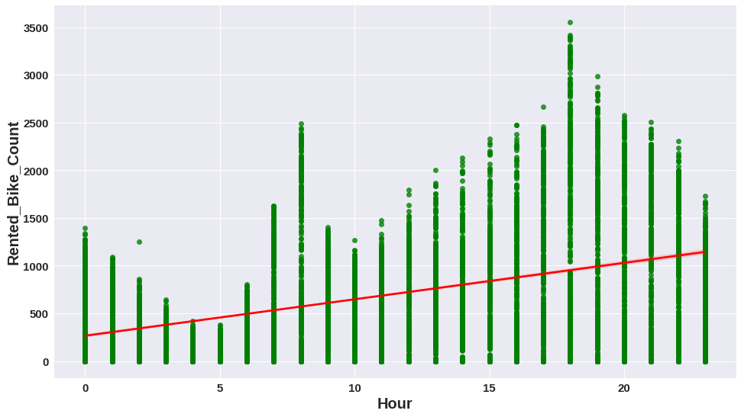

Figure 1. Scatter Plot between Rental Bike Count and Hour of the Day

From the above Scatter Chart, we can observe that data points are closely placed to each other, thereby forming dark linear patterns on the graph.

However, the only secluded point appears to be where the Rented Bike Count exceeds 3500. We have to closely monitor that point over its potential to be an outlier.

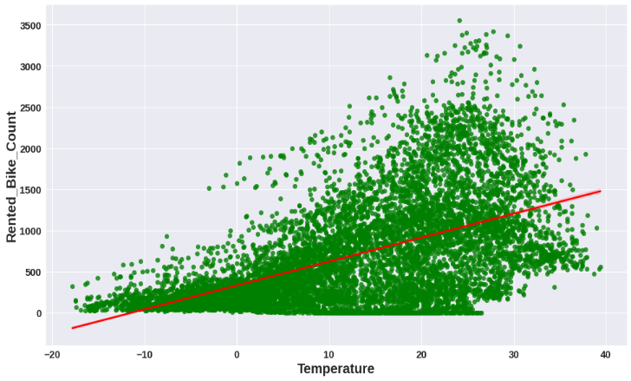

Figure 2. Scatter Plot between Rental Bike Count and Temperature

From the above distribution, Rental Bike Count is spread in form of a cloud which is dense around the region of -20 to 40C. The small tailing clusters towards the higher end of X axis shows that almost all the data points will affect our regression model.

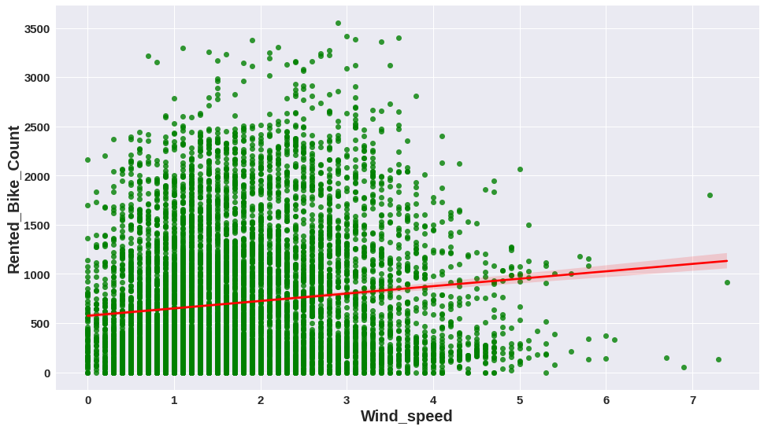

Figure 3. Scatter Plot between Rental Bike Count and Wind Speed

As identified above, in this distribution too, the data points form a prominent cloud around the Wind Speed lying between 0-5 m/s. However, the distribution starts to fade into secluded clusters till breeze of 6m/s.

Post that speed, the data seems to be isolated without any affect from the available data bunch. These points would be considered as potential outliers for our linear regression model.

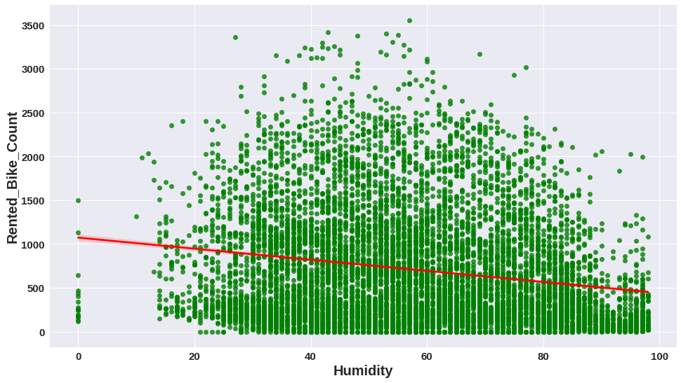

Figure 4. Scatter Plot between Rental Bike Count and Humidity

From the above Scatter Plot, it is evident that data points form a cloud for Humidity ranging between 20 to

100. Also, it understood that Humidity could not be equal to zero, realistically, meaning a possible data discrepancy.

Additionally, the single data point of Rental Bike Count above 3500 which would be taken into consideration during outlier analysis.

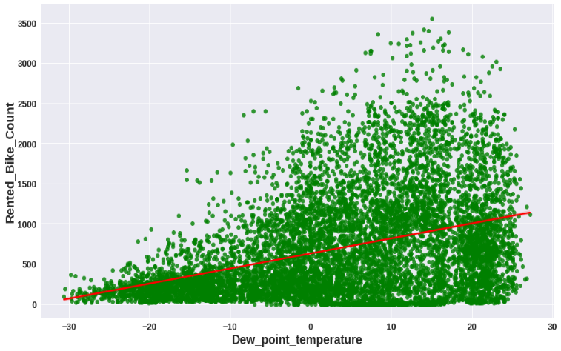

Figure 5. Scatter Plot between Rental Bike Count and Dew Point Temperature

From the above Scatter Plot, the formed data point cloud depicts that Dew Point Temperatures did not make any significant impact until Rental Bike Count reached 500.

After that, there is lightening of the data shade which suggests that Dew Point Temperature made visible effect as number of Rental Bike Counts increased till 3500, where a single data point, again, appears to be secluded.

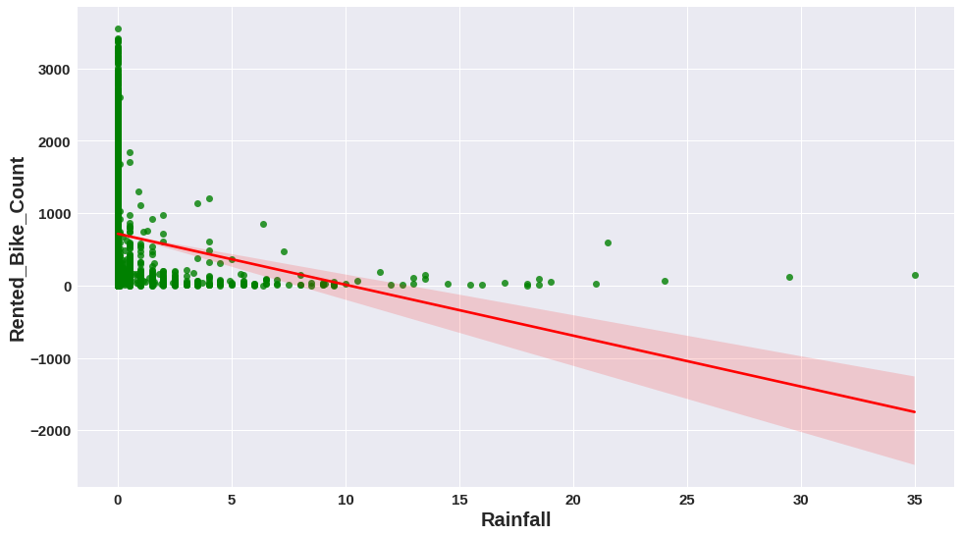

Figure 6. Scatter Plot between Rental Bike Count and Rainfall

As Cycle is an open way to commute between places, Rainfall, almost, will have an inverse relation with the Rental count. The Scatter Plot above also suggests that a significant number of counts lies along the dates when Rainfall was equal to 0 mm.

The scattered clusters above 10 mm to 35 mm show a minimal rise of Rental Bikes from zero. The single data point at 35mm remains an exception and suggests orders for recreational purposes or any other relevant cause. Hence, points above 20 should be considered during outlier analysis.

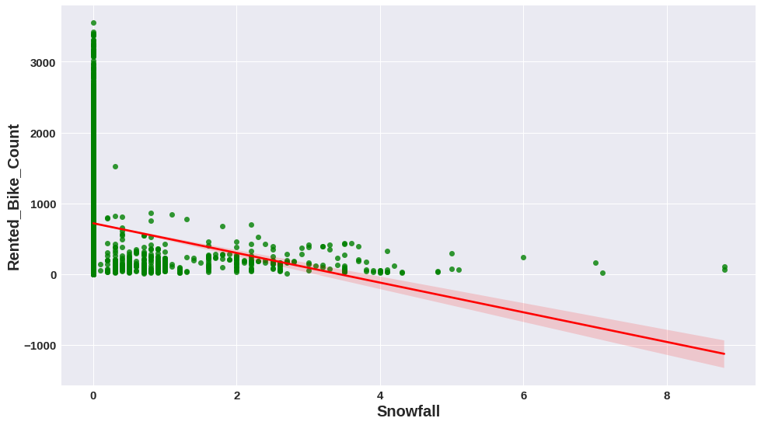

Figure 7. Scatter Plot between Rental Bike Count and Snowfall

As observed in the case of Rainfall, 0 cm Snowfall dominated the Rental Count distribution and clusters lying till

4 cm. Similar to Rainfall, a few data points above 6 cm suggest Rental cycles for recreation or any other relevant cause.

Above scatterplots present a clear picture about how outliers affect the regression model for our dataset. On monitoring data points on multiple visualizations, R was used to trim our dataset initially containing 8700 entries, ending up on 8567 observations.

1. *Correlation Analysis*

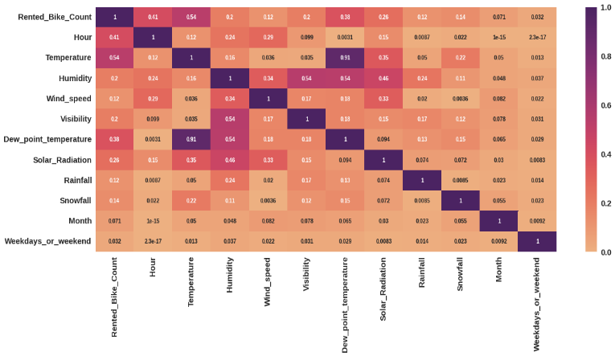

Figure 8. Correlational Analysis of the dataset variables from the above Correlation graph, we can observe that

Temperature and Dew Point Temperature are highly correlated, thereby one of the variables would have to be removed from our Regression model, depending on the significance of each variable.

# RESULTS AND DISCUSSIONS

***Linear Regression:***

Before the outlier treatment we obtained a Regression Model on the dataset containing 8760 observations. The parameters saw a slight improvement after Outlier Treatment and Correlation analysis.

To refine our model, we cleaned a few outliers to obtain an efficient Regression line. Rental Orders above 2500 were removed from our dataset, owing to the scattered distribution leading to noisy data.

Similarly, Rainfall, Snowfall, Solar Radiation, and Wind Speed entries exceeding 10mm, 4cm, 3.5 MJ/m2, and 5m/s respectively were removed from our dataset, too. Our final dataset comprises of 8567 observations.

* The Mean Absolute Error (MAE) is 5.83.
* The Mean Squared Error (MSE) is 58.624.
* The Root Mean Squared Error (RMSE) is 7.656.
* The R2 Score is 0.618.

On testing data R2 score is 0.6183 which is almost close to training data R2 score. Hence, we can say that our model performance is good, and overfitting is not observed. We need to improve our model performance.

***Lasso Regression*:**

* The Mean Absolute Error (MAE) is 5.86.
* The Mean Squared Error (MSE) is 60.464.
* The Root Mean Squared Error (RMSE) is 7.77.
* The R2 Score is 0.61129.

On testing data R2 score is 0. 61129 which is almost close to training data R2 score. Hence, we can say that our model performance is good, and overfitting is not observed. We need to improve our model performance.

***Ridge Regression:***

* The best alpha value is {'alpha': 0.1}
* The best negative mean squared error value is 60.73

Best params are applied on the above ridge model. (Score on ridge is after hyperparameter tuning.)

***ElasticNet Regression:***

* The Mean Absolute Error (MAE) is 5.871.
* The Mean Squared Error (MSE) is 59.29.
* The Root Mean Squared Error (RMSE) is 7.70.
* The R2 Score is 0.6139.
* The best alpha value is {'alpha': 0.0001, 'l1_ratio': 0.5}
* The best negative mean squared error value is -60.7320

Its range is 0 < = l1_ratio < = 1. If l1_ratio = 1, the penalty would be L1 penalty. If l1_ratio = 0, the penalty would be an L2 penalty. *If the value of l1 ratio is between 0 and 1, the penalty would be the combination of L1 and L2.

***Decision Tree Regression:***

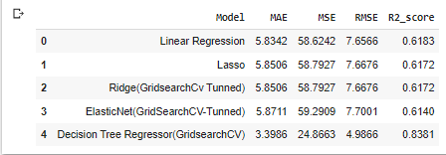

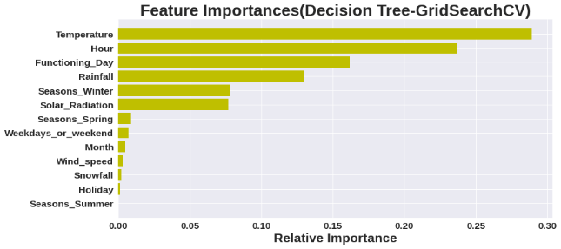

We have applied this best parameter to above Decision tree regressor model.

***Random Forest Regression:***

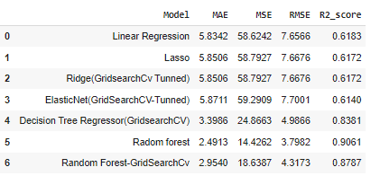

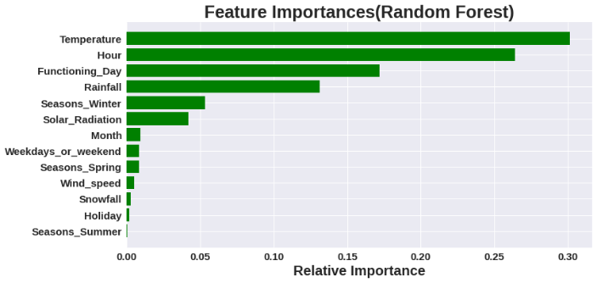

By looking at the graph we can say that temperature and hours plays very important role on bike rentals.

***Gradient Boosting Regression:***

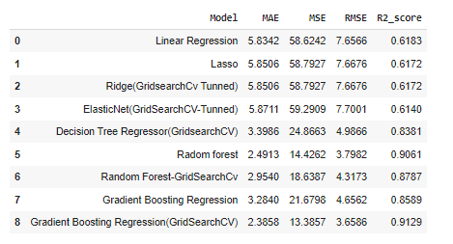

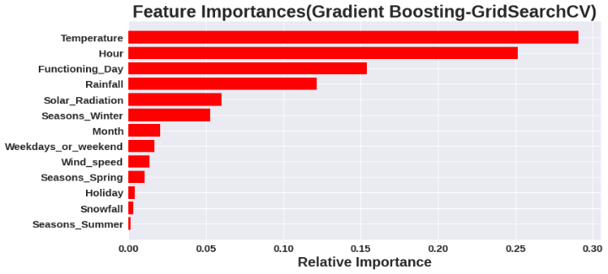

# CHALLENGES

The core challenges of the bike sharing prediction problem are the modeling of the complex spatial and temporal dependencies.

Firstly, or the complex spatial dependencies, the bike sharing usage data distribution is highly imbalanced with varying demands and supplies in different locations of a city. For example, those famous spots are usually accompanied with a much higher demand for various transportation modes including shared bikes than other locations.

Secondly, for the complex temporal dependencies, the bike sharing usage demand may burst in morning evening peak hours because of commuters. But such patterns would not appear in weekends or holidays. Other external factors also make the bike sharing usage patterns complex, e.g., social events or weather.

Thirdly, the complex spatial and temporal dependencies are vulnerable to the changes of bike share systems or nearby environments, for example, the addition of a new bike station or a new shopping mall.

Dealing with such big dataset is quite difficult sometimes, finding missing values made things some more complicated, defining a function which is used to annotate the histogram percent according to their respective count taken a big notch of this obstacle part. Coming to the visualization part, more or less makes our challenges addresses to code in such a way to visualize the graphs as per rows and columns.

# CONCLUSION

As we have calculated MAE, MSE, RMSE and R2 score for each model. Based on r2 score will decide our model performance.

Our assumption: if the difference of R2 score between Train data and Test is more than 5 % we will consider it as overfitting.

Regression models with low R-squared values can be perfectly good models for several reasons.

Some fields of study have an inherently greater amount of unexplainable variation. In these areas, your R2 values are bound to be lower. For example, studies that try to explain human behavior generally have R2 values less than 50%.

People are just harder to predict than things like physical processes.

**Linear,Lasso,Ridge and ElasticNet**:

From The above data frame, we can see that linear,Lasso,Ridge and Elastic regression models have almost similar R2 scores(61%) on both training and test data.(Even after using GridserachCV we have got similar results as of base models).

# Decision Tree Regression:

# On Decision tree regressor model, without hyperparameter tuning we got r2 score as 100% on training data and on test data it was very less. Thus, our model memorized the data. So, it was a overfitted model. After hyperparameter tuning we got r2 score as 88% on training data and 83% on test data which is quite good for us.

**Random Forest:**

On Random Forest regressor model, without hyperparameter tuning we got r2 score as 98% on training data and 90% on test data. Thus, our model memorized the data. So, it was a overfitted model, as per our assumption

After hyperparameter tuning we got r2 score as 90% on training data and 87% on test data which is very good for us.

**Gradient Boosting Regression (Gradient Boosting Machine):**

On Random Forest regression model, without hyperparameter tuning we got r2 score as 86% on training data and 85% on test data. Our model performed well without hyperparameter tuning.

After hyperparameter tuning we got r2 score as 96% on training data and 91% on test data, thus we improved the model performance by hyperparameter tuning.

Thus, Gradient Boosting Regression (GridSearchCV) and Random Forest(gridSearchCv) gives good r2 scores. We can deploy this model.